Skill set code | HLTSS00085
Skill set title | Perform Blood Collection from Children Aged 0 to 5 Years Skill Set
Modification History | Release 1 | New skill set.
Skill set description | This skill set provides pathology collectors with the necessary skills and knowledge to perform blood collection from children 0 to 5 years in a clinical environment.  The skills in this skill set must be applied in accordance with current Commonwealth and State/Territory legislation, Australian/New Zealand standards and industry codes of practice.  No occupational licensing or certification requirements apply to this skill set at the time of publication.
Pathways information | These units provide credit towards the HLT37525 Certificate III in Pathology and other qualifications within the HLT Health Training Package.
Entry requirements | To gain entry into this skill set, a candidate must hold the following units of competency:  HLTPAT012 Perform capillary blood collection  HLTPAT014 Perform venous blood collection
Foundation skills outcomes | The foundation skills outcomes implicit in this skill set are outlined in the below bar chart.  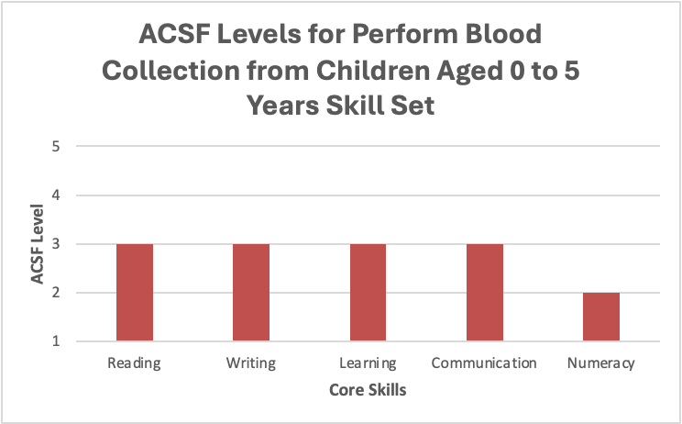  Digital literacy outcomes may be included in the Companion Volume Implementation Guide as appropriate.
Skills set requirements | HLTPAT013 Perform venous blood collection from children 0 to 5 years  “Units listed in italics have prerequisite units of competency, which are also included as an entry requirement for this skill set.”
Skill set mapping information | No equivalent skill set.
Links | Link to Companion Volume Implementation Guide  https://vetnet.gov.au/Pages/TrainingDocs.aspx?q=ced1390f-48d9-4ab0-bd50-b015e5485705

